**10/1/2018**

**Donport4 Router Setup**

There is the FIOS MODEM, a NETGEAR ROUTER, and A NETGEAR EXTENDER.

These are my products, from <https://www.netgear.com/mynetgear/portal/myProducts.aspx>

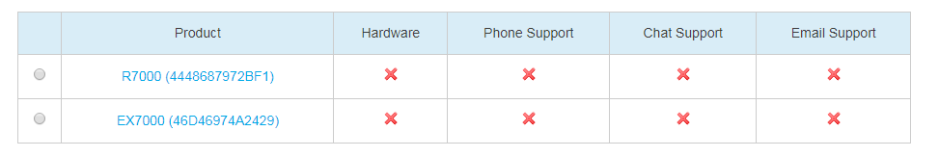

The email from Netgear will tell you the latest firmware versions for the 2 Netgear items. For example, on 10/1/2018, it shows

R7000: Latest firmware version: v 1.0.9.34 (router)

EX7000: Latest firmware version: v 1.0.1.78 (extender). This gave me

Don Bellenger/Dropbox/Downloads/EX7000-V1.0.1.78_1.0.140.zip. I then extracted all, and got a .chk file. The .chk file is the one you want.

# Router

Log in to [www.routerlogin.net](http://www.routerlogin.net) admin/PhtfrJh$ This gives you a browser-based “genie”. The top of the screen shows NETGEAR genie. After updating the firmware, check that the Firmware Version showing in the top right of the banner is the latest version.

# Extender

This link let me download the latest update for the EXTENDER.

<https://www.netgear.com/support/product/EX7000.aspx#Firmware%20Version%201.0.1.78>

It is important to do this before trying to apply the update to the extender, because the Extender network can’t talk to the Internet to find the file on the spot. So instead, browse your local machine for the update file.

This is the link to apply the update to the extender.

You must be connected to the extender (not the router) to apply the update to the extender. Example: Y3D3B-2G_2GEXT.

<http://www.mywifiext.net/>

Login: [Donald.bellenger@gmail.com/orange123](mailto:Donald.bellenger@gmail.com/orange123)

After applying an update, this will tell you that you are not connected to the Internet. When you say OK, it gives you a change to browse for the .chk file downloaded above. After you click upload and wait 2 minutes, the extender will restart. And you will get I HAVE CONNECTED TO THE EXTENDER NETWORK.

Restart Donport4. Cross your fingers. See if you can connect to Y3D3B-2G_2GEXT. If so, try <http://www.mywifiext.net/>

again, in Chrome. If things are good, you will get AC1900 WiFi Range Extender. You can connect Firmware Update, and verify “your firmware is up to date”.